**Experient-4**

**Design and Configuration of RING Topologies using Packet Tracer. Step1:** 4 switches and 4 PCs

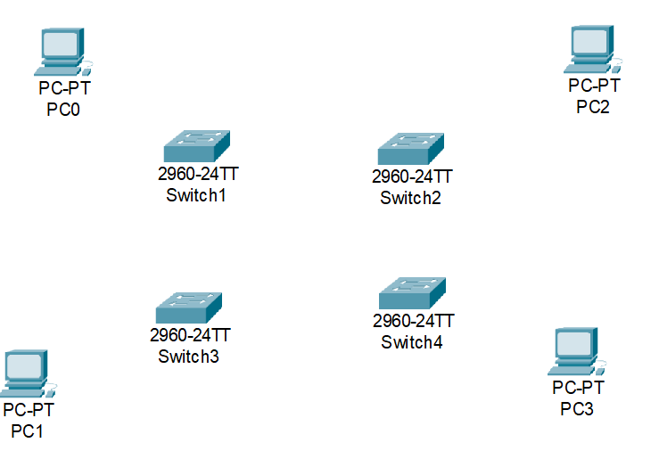

**Step2:** connect fast ethernets from switch to switch and switch to PCs

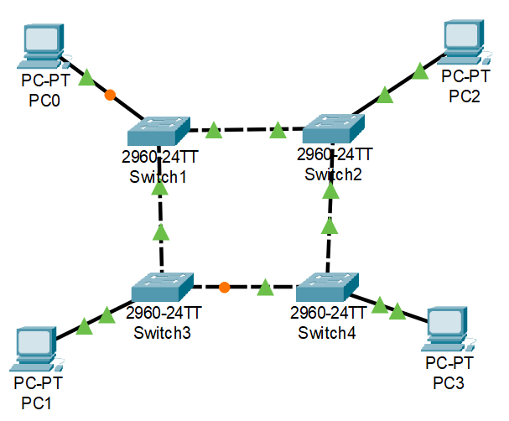

**Step3:** Assign IP address for each PCs

IP address for PC0:192.168.1.1

IP address for PC1: 192.168.1.2

IP address for PC2: 192.168.1.3

IP address for PC3: 192.168.1.4

**Step4:** allocate the message

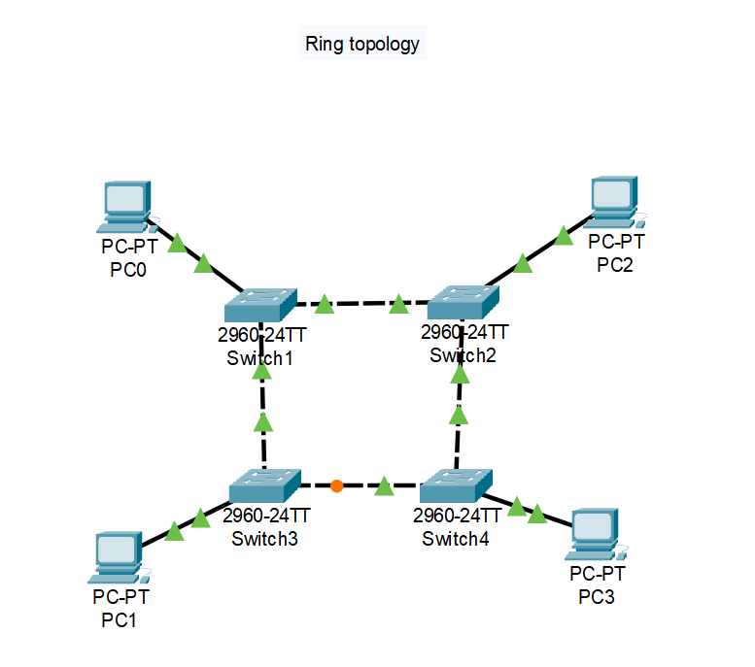

**Result:** message sent successfully from PC1-PC2